**EPEL** (Extra Packages for Enterprise Linux)

[**EPEL**](https://fedoraproject.org/wiki/EPEL) is known as “**Extra Packages for Enterprise Linux**” repository having lots of extra packages which is not added in official repositories. [REMI](http://rpms.famillecollet.com/) is a third party repository provides latest version of packages which is already included in official repositories of CentOS and Red Hat.

**Why we use EPEL repository ?**

* Provides lots of open source packages to install via Yum.
* Epel repo is 100% open source and free to use.
* It does not provide any core duplicate packages and no compatibility issues.
* All epel packages are maintained by Fedora repo.

**How To Enable EPEL Repository in RHEL :-**

1. Install epel rpm Package

# wget <http://download.fedoraproject.org/pub/epel/6/i386/epel-release-6-8.noarch.rpm>

# rpm –ivh epel-release-6-8.noarch.rpm

1. Open and Edit /etc/yum.repos.d/ epel.repo And /etc/yum.repos.d/ epel-testing.repo and Changes the Following in Both File.

Uncommend the following Line :–

baseurl=http://download.fedoraproject.org/pub/epel/testing/6/$basearch/debug

Commend the following Line :–

#mirrorlist=https://mirrors.fedoraproject.org/metalink?repo=testing-debug-epel6&arch=$basearch

1. # yum repolist

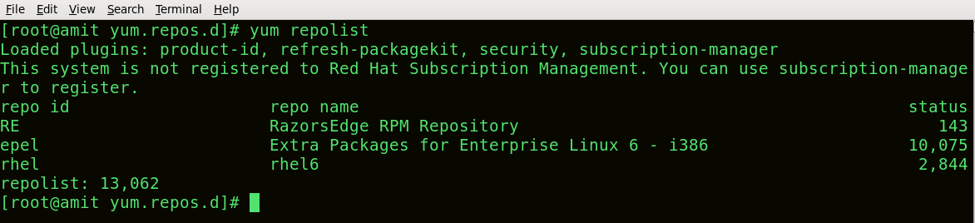

* <http://www.tecmint.com/how-to-enable-epel-repository-for-rhel-centos-6-5/>
* [https://www.unixmen.com/install-remi-repository-rhel-centos-scientific-linux-76-x5-x- fedora-201918/](https://www.unixmen.com/install-remi-repository-rhel-centos-scientific-linux-76-x5-x-%20%20%20%20fedora-201918/)